PUBLIC STATEMENT

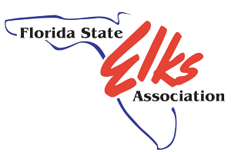
CONTACT INFORMATION:
Florida State Elks Association
Media Relations
Laz Suarez
305-505-4215
Laz@floridaelks.org

RELEASE DATE:
October 26, 2021

MEDIA ALERT –NOTICE FOR IMMEDIATE RELEASE
Public Statement following incident at Elks Lodge

Dateline: City, Florida, October 26 — We are saddened and deeply disappointed by the events that took place on our property by outside persons. This behavior is not our culture and will not be tolerated. We are fully cooperating with law enforcement in their investigation and, unfortunately, we cannot comment further at this time.

The Elks are a non-political, non-sectarian and strictly American organization started in 1868. We spend more than $80,000,000 every year nationally for benevolent, educational and patriotic community-minded programs. The Florida Elks provide scholarships for students, free in-home physical therapy for over 500 kids per week including 37 employed physical and occupational therapists who provide free therapy to autistic children. We also provide and support programs for scouting, scholastic athletics, and veterans’ services.

To learn more visit www.floridaelks.org
For membership information visit Join.Elks.Org

CONTACT INFORMATION:

Laz Suarez- 305-505-4215

